

# Reach Best Coding Creativity Challenge

Genre Web App

The challenge for this web app was to match personality with the book genre. So this web app is React+Django web app that takes 2 input criteria and predicts the book genre based on person’s personality

Front End of the app is in React as it was the required stack

Backend of the app is in Django (Python) because Django is a full-featured Python web framework known for its rapid development, built-in features, and Django ORM. It leverages a rich Python ecosystem, includes a customizable admin interface, and follows secure-by-default principles. The framework's consistency, conventions, and scalability make it a strong choice for a backend stack in various web development scenarios.

**App Contains a Input form, Visual Representation Block and a fixed navbar(can be altered).**

There are some research done on correlating the User’s personality with their favourite books genres. Searching over various research papers it got me that there are big five models to tell about user’s personality and those are:

**Extraversion, Agreeableness, Openness, Neuroticism and Conscientiousness.**

Of which Openness and Conscientiousness have highest correlation

So using web scrapping tools I collected data on openness and conscientiousness and their combined results of genres available.  
  
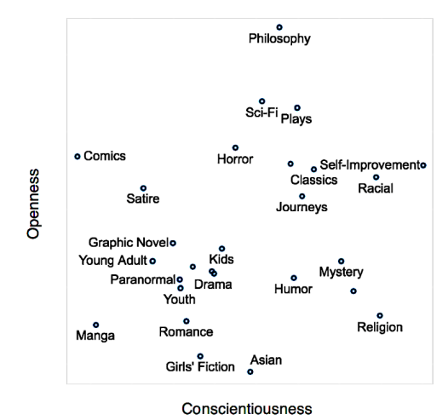

From this graph and available tools created csv dataset (check in folder)

What app does take comma separated values of

Openness on basis of (Imagination, Artistic, Creativity, Adventurous) all scored in (1-5)   
eg-(2,3,5,4)

Conscientiousness on basis of(Discipline, Responsibility, Organised, Cautious) all scored in

(1-5).

Eg-(3,4,2,5)

And thus app will take the value and return the genre suggested and vector graph of Openness and Conscientiousness.

**Run the app**

Open Terminal 1 move to **book-matching-frontend** folder and type **npm start**

Open Terminal 2 move to **book_matching** folder and type **python manage.py runserver** to start the backend server.

Here is the example of app input and output display

